Cointegration and ECM: USDCHF and EURGBP
Method 27 / Engle-Granger on log closes / one-lag ECM / Alpari D1 full available history

Study setup
Logical pair: PX=USDCHF , PY=EURGBP
Broker symbols: USDCHF_i , EURGBP_i
Snapshot: 2026-11-03_majors_alpari_D1
Timeframe: D1
Matched window: 1999-01-06 to 2026-11-02 (UTC bar dates)
Matched level count n: 7182
Dropped unfinished last bar dated 2026-11-03 UTC after a tick-volume check against the prior complete day.
ECM lags of deltas: 1
Complete matched rows (Excel): USDCHF-EURGBP_Coint_D1.xlsx
Complete matched rows (HTML table): USDCHF-EURGBP_Coint_D1_data.html

Method carried forward
Engle-Granger cointegration works on log price levels, not returns. For each unordered pair, PX is the left leg and PY the right leg. Step one: OLS ln(PY) = alpha + beta * ln(PX) + e. Step two: statsmodels Engle-Granger coint test on (ln(PY), ln(PX)). Error-correction: delta ln(PY)_t = c + kappa * e_{t-1} + lagged delta ln(PY) and delta ln(PX) (one lag each) + u_t. Headline is the Engle-Granger p-value (lower = stronger evidence of a stationary spread) with kappa and beta reported alongside. Same-sample Pearson r of log returns is a side check only. beta is not an automatic lot-size hedge. This is not a trading signal.

Results (headline)
alpha: -0.210484
beta: -0.532874
Engle-Granger t: -2.829042
Engle-Granger p: 0.156619
5% critical value: -3.336981
ECM kappa: -0.001828
kappa t-stat: -1.9664
ECM R^2: 0.001747
spread std: 0.061851
Pearson r (returns): -0.325886

Conclusion
Engle-Granger for PY=EURGBP on PX=USDCHF: beta=-0.5329, alpha=-0.2105, coint_t=-2.8290, p=0.1566 (5% crit=-3.3370). ECM kappa=-0.0018 (t=-1.97). Pearson r of returns = -0.3259. beta is not a lot-size hedge. Not a trading signal.

Charts
Daily closes

Engle-Granger residual spread
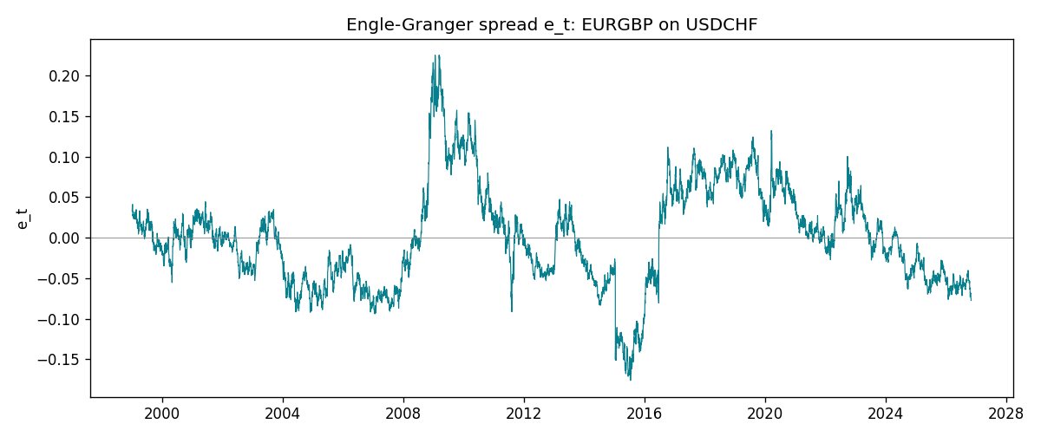
Daily log returns
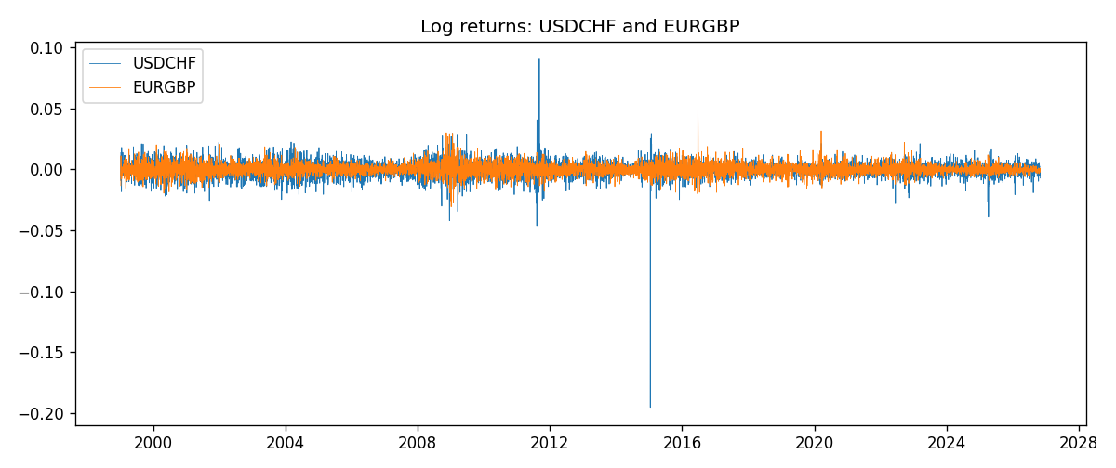

Data report
Matched rows are in the sibling Excel workbook named USDCHF-EURGBP_Coint_D1.xlsx. Embedding all rows as a Word table is impractical; this file holds column summaries and the first and last 15 matched rows.
Column summaries
column | count | mean | std | min | 25% | 50% | 75% | max
USDCHF_open | 7182 | 1.0972493 | 0.25210985 | 0.72022 | 0.9204925 | 0.989875 | 1.237175 | 1.8219
EURGBP_open | 7182 | 0.7869939 | 0.09664695 | 0.5734 | 0.6877 | 0.833905 | 0.865225 | 0.9769
USDCHF_high | 7182 | 1.1025378 | 0.25385182 | 0.73305 | 0.924695 | 0.99351 | 1.242175 | 1.8313
EURGBP_high | 7182 | 0.79007306 | 0.09702085 | 0.5789 | 0.6897 | 0.836955 | 0.8681 | 0.9799
USDCHF_low | 7182 | 1.092133 | 0.25052689 | 0.08565 | 0.9171825 | 0.986205 | 1.2312 | 1.8121
EURGBP_low | 7182 | 0.7842938 | 0.09646529 | 0.5682 | 0.685725 | 0.83166 | 0.86287 | 0.9661
USDCHF_close | 7182 | 1.09724 | 0.25200902 | 0.72025 | 0.9207375 | 0.98991 | 1.23715 | 1.8217
EURGBP_close | 7182 | 0.78703952 | 0.09664503 | 0.5735 | 0.687825 | 0.83398 | 0.865375 | 0.977
USDCHF_tick_volume | 7182 | 74362.695 | 113509.88 | 18 | 12814.25 | 40258.5 | 70446 | 858589
EURGBP_tick_volume | 7182 | 87145.49 | 145506.26 | 154 | 6593.75 | 44371 | 81432 | 1424684
USDCHF_spread | 7182 | 26.020746 | 24.692144 | 0 | 5 | 16 | 50 | 100
EURGBP_spread | 7182 | 21.320663 | 19.117614 | 0 | 4 | 13 | 40 | 50
USDCHF_real_volume | 7182 | 2.3303821e+10 | 8.915094e+10 | 0 | 0 | 0 | 0 | 1.9331921e+12
EURGBP_real_volume | 7182 | 2.7876168e+10 | 1.3522356e+11 | 0 | 0 | 0 | 0 | 3.5726265e+12
USDCHF_log_price | 7182 | 0.06937199 | 0.21048036 | -0.32815691 | -0.0825803 | -0.01014125 | 0.21281034 | 0.59977013
EURGBP_log_price | 7182 | -0.2474506 | 0.12808305 | -0.55599734 | -0.37422084 | -0.18154586 | -0.14459234 | -0.02326863
USDCHF_log_return | 7182 | -7.199e-05 | 0.00659004 | -0.19545699 | -0.00335239 | 7.626e-05 | 0.00331734 | 0.09051364
EURGBP_log_return | 7182 | 2.529e-05 | 0.00487429 | -0.03067367 | -0.00262165 | -0.00010006 | 0.00256425 | 0.06075387
spread_e | 7182 | -0 | 0.06185083 | -0.17614151 | -0.04559221 | -0.00319577 | 0.03663398 | 0.22504926
ecm_fitted | 7181 | 2.715e-05 | 0.00020364 | -0.0051697 | -8.647e-05 | 3.458e-05 | 0.00014809 | 0.00254338
First 15 matched rows (selected columns)
time | USDCHF_log_price | EURGBP_log_price | spread_e | USDCHF_log_return | EURGBP_log_return
1999-01-06 | 0.33016668 | -0.35396434 | 0.032456898 | 0.013605652 | -0.013303338
1999-01-07 | 0.3207783 | -0.34291293 | 0.038505477 | -0.0093883841 | 0.011051402
1999-01-08 | 0.33181857 | -0.3478568 | 0.039444683 | 0.011040268 | -0.004943862
1999-01-11 | 0.33711489 | -0.34913203 | 0.040991713 | 0.0052963193 | -0.0012752393
1999-01-12 | 0.32728733 | -0.345735 | 0.039151896 | -0.0098275602 | 0.0033970309
1999-01-13 | 0.30902763 | -0.34531119 | 0.029845601 | -0.018259701 | 0.00042381861
1999-01-14 | 0.30660196 | -0.34729054 | 0.026573667 | -0.0024256692 | -0.0019793588
1999-01-15 | 0.32454424 | -0.35496213 | 0.028463053 | 0.01794228 | -0.0076715819
1999-01-18 | 0.3213586 | -0.35424932 | 0.02747832 | -0.0031856384 | 0.00071280921
1999-01-19 | 0.32128608 | -0.35567544 | 0.026013549 | -7.2518946e-05 | -0.0014261269
1999-01-20 | 0.32851207 | -0.35367943 | 0.031860096 | 0.0072259871 | 0.0019960086
1999-01-21 | 0.3246888 | -0.35439184 | 0.029110374 | -0.0038232689 | -0.00071240297
1999-01-22 | 0.32454424 | -0.35610368 | 0.027321501 | -0.0001445609 | -0.0017118406
1999-01-25 | 0.32699893 | -0.36154392 | 0.023189302 | 0.0024546976 | -0.0054402425
1999-01-26 | 0.3290879 | -0.3621183 | 0.023728072 | 0.0020889617 | -0.00057438255
Last 15 matched rows (selected columns)
time | USDCHF_log_price | EURGBP_log_price | spread_e | USDCHF_log_return | EURGBP_log_return
2026-10-13 | -0.18339413 | -0.16891582 | -0.056157627 | -0.0024955621 | 0.00020130374
2026-10-14 | -0.1804553 | -0.16779163 | -0.053467413 | 0.0029388325 | 0.0011241873
2026-10-15 | -0.19024083 | -0.1686672 | -0.05955744 | -0.0097855323 | -0.00087557391
2026-10-16 | -0.19386391 | -0.17070529 | -0.063526169 | -0.0036230826 | -0.0020380844
2026-10-19 | -0.19022874 | -0.1712748 | -0.062158589 | 0.0036351779 | -0.00056950988
2026-10-20 | -0.19285686 | -0.17486542 | -0.067149671 | -0.0026281224 | -0.0035906254
2026-10-21 | -0.19325713 | -0.17627189 | -0.068769437 | -0.00040027413 | -0.00140647
2026-10-22 | -0.19806077 | -0.17814629 | -0.073203562 | -0.0048036381 | -0.0018743924
2026-10-23 | -0.19240826 | -0.17732208 | -0.069367275 | 0.005652514 | 0.00082421033
2026-10-26 | -0.19056746 | -0.17719074 | -0.06825503 | 0.0018407959 | 0.00013133309
2026-10-27 | -0.18795741 | -0.17918648 | -0.068859936 | 0.0026100526 | -0.0019957343
2026-10-28 | -0.18897162 | -0.1785168 | -0.068730711 | -0.0010142111 | 0.00066967224
2026-10-29 | -0.19383964 | -0.17968902 | -0.072496969 | -0.0048680164 | -0.0011722209
2026-10-30 | -0.19312369 | -0.18210958 | -0.074536015 | 0.00071594559 | -0.0024205543
2026-11-02 | -0.20026966 | -0.18121017 | -0.077444512 | -0.0071459744 | 0.00089940465

